**Week6day1 HW**

1. What is crontab and what is it used for?

Crontab it is a Linux command used to schedule and execute tasks automatically in the backend.

1. How do you schedule, list, and delete a cronjob?

Crontab -l to list

Crontab -r to delete

Crontab -e to execute

1. What means * * * * * and how do you represent twice every hour?

***** it is a cron schedule expression meaning that our tasks will run every minute, every hour, everyday of every month, every month and each day of a week.

Twice every hour = * /30 * * * *

1. What are the 5 field & allowed values in each field of the crontab

Minutes, hour, day (month), month, day (week)

1. Create a job that will run twice every minute and send its content in a file call success.txt. get the screen shot of the content after 3 minutes with the first line saying “I am so close to be a DevOps Engineer making $150K/year”

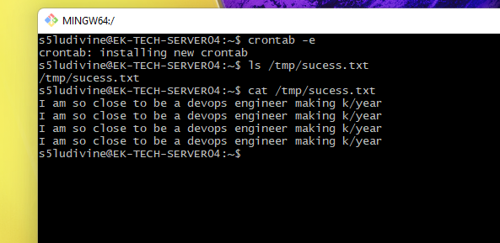

I did it every minute, I could not find the formula to do it twice every minute

1. Provide the meaning of each part of the output of the long list command

r read, w writes, x executes, - no permission

1. What command is used to change permission on a file?

Chmod command is used to change permission on a file

1. What happen if we set a permission 2

If we set permission 2 that means the user is only able to write, the group and other cannot do anything. -w-------

1. What is the issue when you have permission denied while trying to run a script?

You do not have permission to run that specific script

1. What is the permission 641 means and provide the symbolic value and the result on how it looks on long list cmd

641 means: the user can only read and write 4+2, the group can only read 4, others can only execute 1. We will have on the long list cmd rw-r----x

1. What is the result for the permission rwx-xr-x and rwxr-xrwx after applying the symbolic value of o-rx and -x respectively?

With o-rx we have: -w------ and -w-----w-

With o-x we have: rw---r—and rw-r--rw-

1. What other steps are important to be able to login as a new user that I just created with useradd on ubuntu and be able to login as that user and work properly?

We must create: the password of the new user by running the cmd passwd s5ludivine1

His home directory by running the cmd mkdir -p /home/s5ludivine1

We should also assign to the new user proper permission (change ownership) by running the command chown -R s5ludivine1:s5ludivine1/home/s5ludivine1

1. How do you troubleshoot a slow server, be more specific on many scenario

I will run the command top to check if the processes used a lot of memory. If so, I will let the lead know and ask which processes can be killed. The other solution is to add more CPUs to the system or increase the speed of the cpu.

I will run the command df -h / to check the state of the HDD if it is full, I can add more disk or delete some data with the approbation of the lead.

I will also run free command to check the amount of the physical and swap memory as well as the free and used memory.

1. What is the difference between the soft and hard kill? And which one is advice to use?

The soft one kill all the child processes before terminating the parent process. The soft kill is the one advice to use because it’s smooth and kill child processes gracefully.

We run the command kill -15

On the other hand, we run the command kill -9 for the hard kill, it does not check the state of the processes and kill them immediately.

1. What happen to an orphan process before and after it become orphan?

A child process became an orphan because his parent has been killed forcedly, without waiting for child to terminate.

After being an orphan, the child process is adopted by an init process.

1. What created a zombie process?

A child process creates a zombie process. A child process always first becomes a zombie before being removed from the process table.s